Name : Ajey Srinivasu
Date : 15/02/2026

- Open VS Code
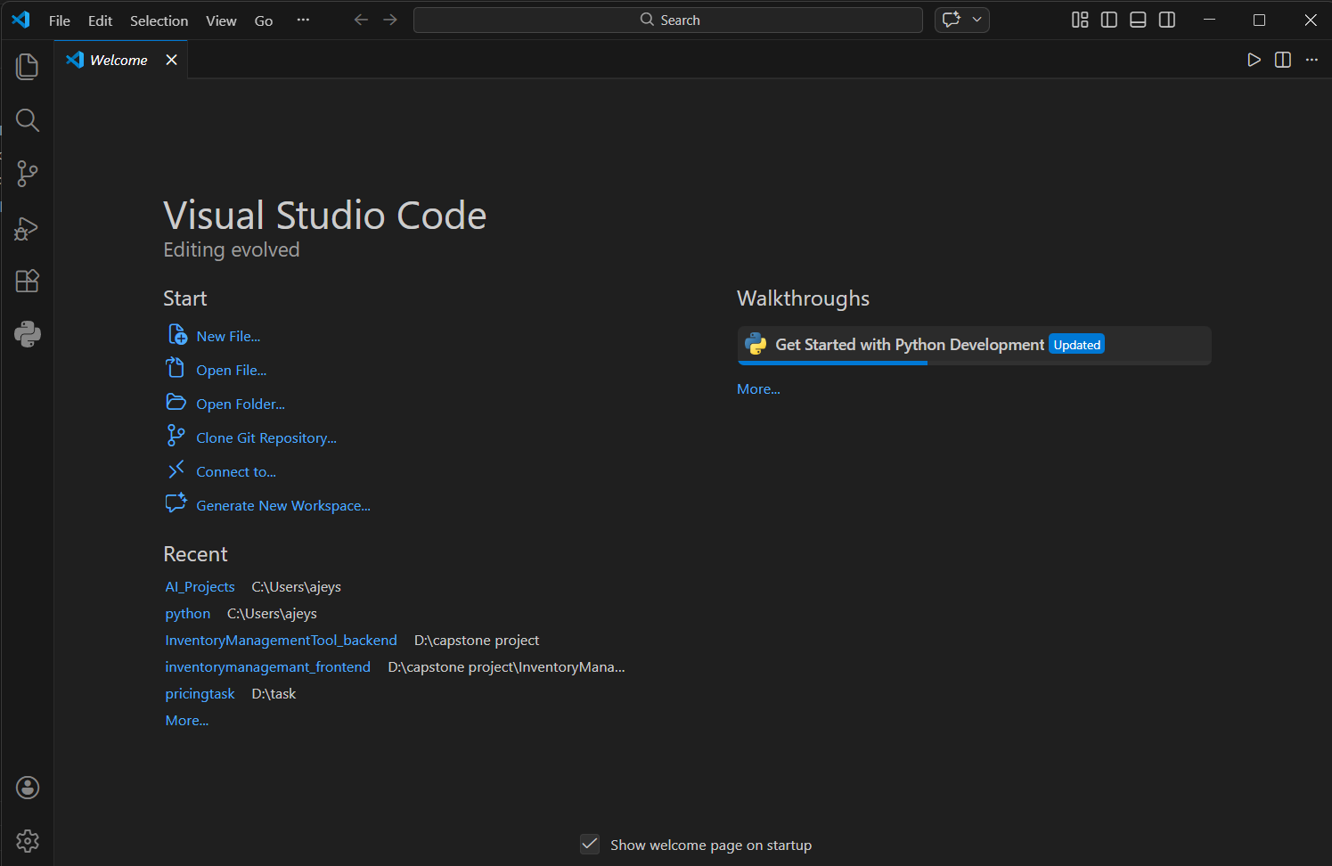

Python extension installed

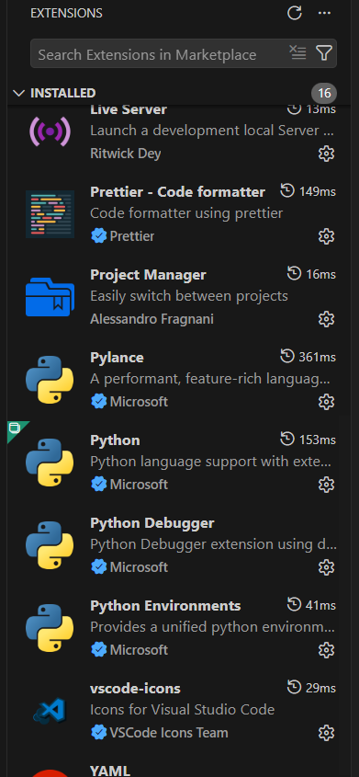

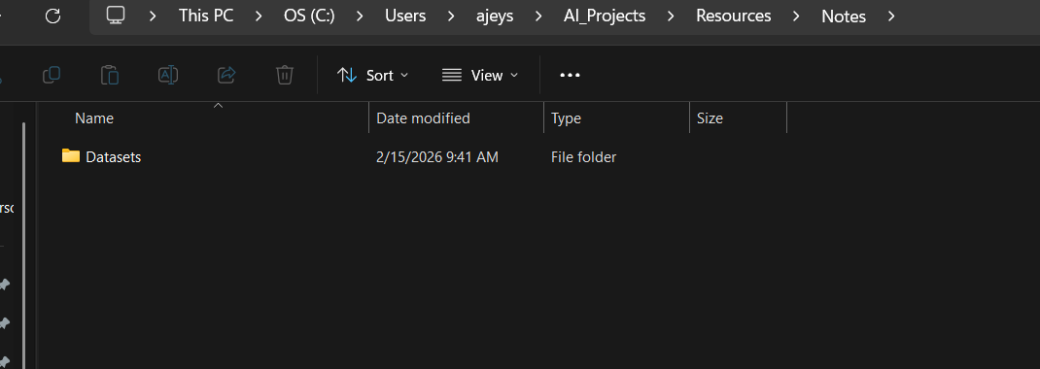

In Vs code

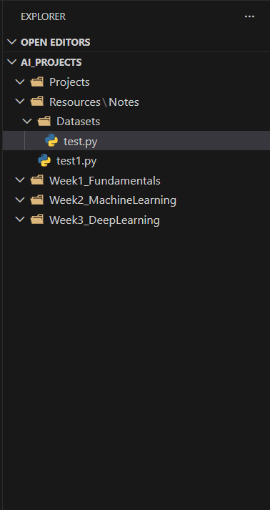

Why is an organized folder structure important for AI projects?

Folder structure makes it easy to locate and modify components.Reduces Debugging Time and Without structure, everything becomes messy and hard to debug.Maintain the resource and logic separately. Easy to push the specific changes to github .
How will you use this setup in your learning?

Help us to maintain learning and practice for each session .
To identify the topic learn for the session and help to clarify the doubt without messy

